Database Exercise submission deadline friday 19th july 2019

question 1:

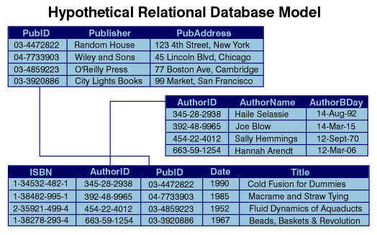

Create the database above named Library with the topmost table named Publisher with PubID as the primary key,the second Table called Author with AuthorID as the primary key and the lower most table called Book with ISBN as the primary key.

Use appropriate field type for the fields above

Create the relationships as indicted by the arrows

Create queries of your own choosing: 2 queries involving one table, 2 queries involving two of the tables and 2 queries involving the three tables

Create 2 reports :

* 1. Report showing Publisher, AurthorName and Title and Date. This report is grouped by Publisher
  2. Report showing AuthorName and Title and Date. This report is grouped by AuthorName.

Question 2:

create a primary school database that keeps track of results for a particular class. Example tables may student, subjects(math,English,science and sst),teacher and results. Define your own columns that you thin are appropriate. Add a report to show results for every student and results for every teacher.